Screenshot of VS Code

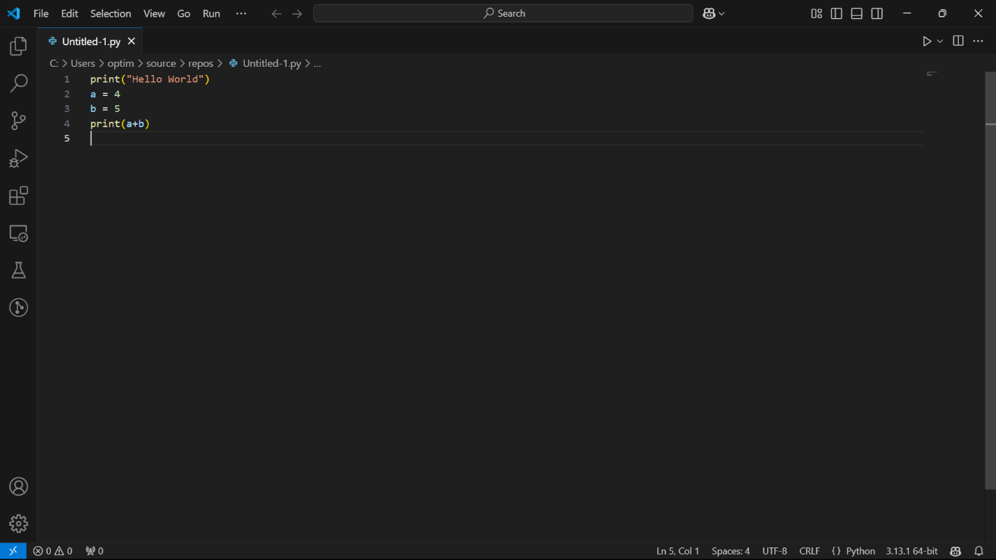

Screenshot of Anaconda Jupyter notebook

